GOVERNMENT ENGINEERING COLLEGE, BHARUCH

Student's Weekly Report of Internship
Student Name: | PATEL BINIT UMESHKUMAR
Enrollment Number: | 230143107014
Week Duration: | February 5, 2026 - February 11, 2026 (Week 6)
Name Of Organization: | Microsoft Elevate Program (via Edunet Foundation & FICE Education)
External Guide Name: | Adarsh Gupta
External Guide Contact: | 0124-4080107

Work done in last Week with description:

1. Week 6 Module: Deep Learning Fundamentals

Description:
Attended comprehensive session on "Deep Learning" on February 27, 2026. This session introduced neural networks, deep learning architectures, and their applications in computer vision, natural language processing, and other domains.

Key Topics Covered:
- What is Deep Learning? Relationship with AI and ML
- Neural networks: biological inspiration and mathematical model
- Perceptron: the basic building block
- Deep neural networks: multiple hidden layers
- Activation functions: Sigmoid, Tanh, ReLU, Leaky ReLU
- Forward propagation: computing outputs
- Backpropagation: gradient descent and weight updates
- Loss functions: MSE, Cross-Entropy
- Optimizers: SGD, Adam, RMSprop
- Overfitting and regularization techniques

Understanding Developed:
Understood how neural networks learn through iterative weight adjustments. Learned the importance of choosing appropriate activation functions and optimizers. Recognized why deep learning excels at tasks like image recognition, which is directly applicable to the surveillance project.
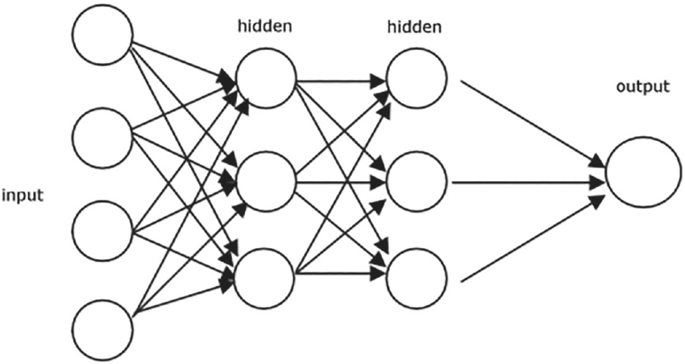
Figure 1: Basic artificial neural network architecture showing input layer, hidden layers, and output layer with weighted connections.

2. Week 6 Module: Artificial Neural Networks (ANN)

Description:
Participated in "Artificial Neural Networks (ANN)" session on March 2, 2026. Learned to build and train neural networks using TensorFlow and Keras frameworks with hands-on implementation.

Key Topics Covered:
- Introduction to TensorFlow 2.x and Keras API
- Sequential model vs Functional API
- Adding layers: Dense, Dropout, BatchNormalization
- Compiling models: loss, optimizer, metrics
- Training models: fit(), epochs, batch size
- Model evaluation and prediction
- Callbacks: EarlyStopping, ModelCheckpoint
- Visualization: training history plots
- Hyperparameter tuning for neural networks

Hands-on Practice:
Built feedforward neural network for MNIST digit classification. Created multi-layer architecture with 784 input neurons, two hidden layers (128 and 64 neurons), and 10 output neurons. Used ReLU activation in hidden layers and Softmax for output. Achieved 97% accuracy on test set. Practiced with different optimizers and learning rates to understand their impact on training.
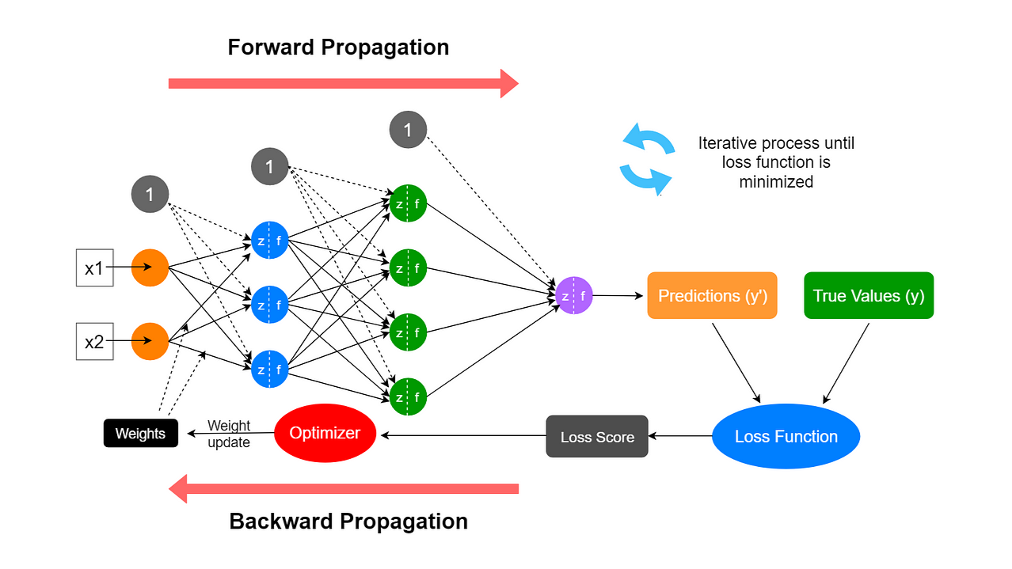
Figure 2: Neural network training process showing forward propagation, loss calculation, and backpropagation for weight updates.

3. TensorFlow and Keras Environment Setup

Description:
Installed and configured deep learning environment with TensorFlow, Keras, and related libraries. Setup both local environment and Google Colab for GPU-accelerated training.

Setup Completed:
- Installed TensorFlow 2.15 with GPU support
- Verified CUDA and cuDNN installation (for GPU acceleration)
- Setup Google Colab account for cloud GPU access
- Installed supporting libraries: numpy, matplotlib, seaborn, PIL
- Tested GPU availability with tf.config.list_physical_devices('GPU')
- Created Jupyter notebooks for practice exercises

4. Week 7 Preview: Introduction to CNN

Description:
Attended introductory session on "Convolutional Neural Networks (CNN)" on March 6, 2026. This session provided foundation for understanding CNNs, which are crucial for image-based tasks and object detection.

Key Topics Covered:
- Limitations of fully connected networks for images
- Convolution operation and feature maps
- Convolutional layers: filters, kernels, strides
- Pooling layers: Max Pooling, Average Pooling
- CNN architecture: Conv → ReLU → Pool → Flatten → Dense
- Parameter sharing and spatial hierarchy
- Famous CNN architectures: LeNet, AlexNet, VGG
- Applications in image classification and object detection

Understanding Gained:
Understood why CNNs are superior for image tasks - they preserve spatial relationships and detect features regardless of position. Recognized how convolutional layers automatically learn features like edges, textures, and complex patterns. This knowledge is essential for implementing YOLOv8, which is built on CNN architecture.
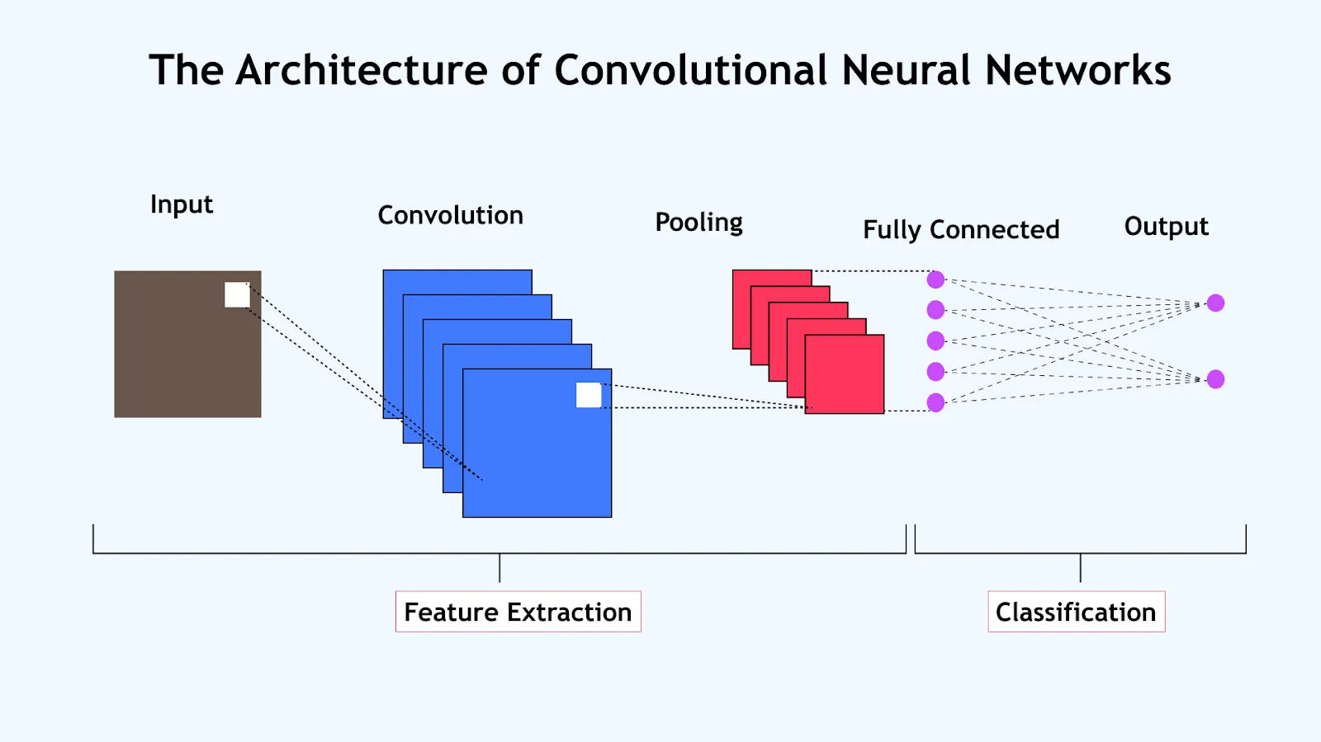
Figure 3: Convolutional Neural Network architecture illustrating convolution, pooling, flattening, and dense layers for image classification.

5. Deep Learning Assignment Completion

Description:
Completed comprehensive deep learning assignment covering neural network implementation, training, and evaluation using TensorFlow/Keras.

Assignment Tasks:
- Task 1: Build ANN for binary classification (2 classes)
- Task 2: Build ANN for multi-class classification (MNIST dataset)
- Task 3: Implement regularization techniques (Dropout, L2)
- Task 4: Compare different optimizers (SGD, Adam, RMSprop)
- Task 5: Visualize training history (loss and accuracy curves)
- Task 6: Save and load trained models
- Submitted Jupyter notebook with complete implementation
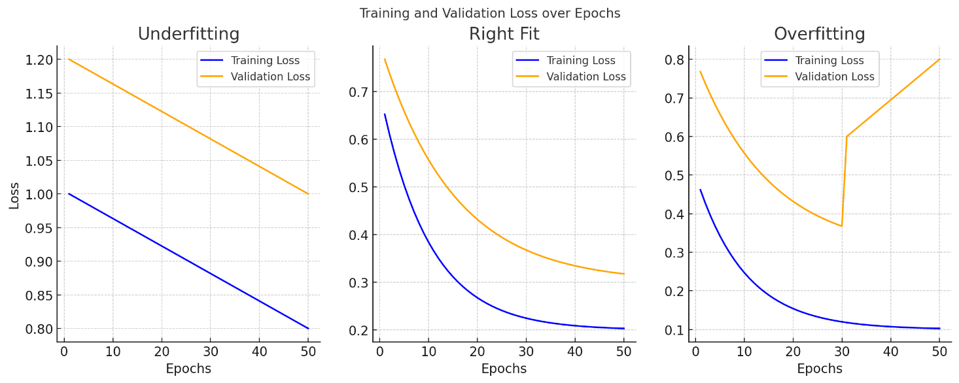
Figure 4: Training and validation accuracy/loss curves used to evaluate neural network performance and detect overfitting.

6. GTU Project - Research on YOLOv8 Architecture

Description:
Started researching YOLOv8 architecture and object detection concepts. Primary focus remained on completing deep learning modules, with project implementation planned for Week 7-8 after CNN mastery.

Research Completed:
- Studied YOLOv8 documentation and architecture overview
- Understood YOLO concept: single-shot object detection
- Learned about bounding boxes, confidence scores, and IoU
- Reviewed Ultralytics YOLOv8 library documentation
- Listed requirements: Python 3.8+, PyTorch, Ultralytics package

Next Steps Identified:
Will install YOLOv8 and test pre-trained model in Week 7. Will prepare custom dataset annotation for fine-tuning. Implementation will accelerate after completing TensorFlow & Keras module and CNN deep dive in Week 7.
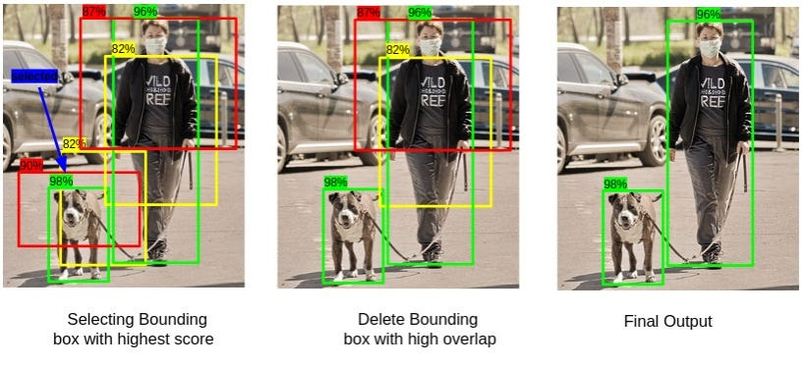
Figure 5: Object detection output showing bounding boxes, confidence scores, and class predictions used in YOLO-based systems.

Plans for next week (Mar 10-14, 2026):

1. Complete Week 7 Microsoft Elevate Modules
- Attend "TensorFlow & Keras" advanced session (Mar 9)
- Participate in "Generative AI" introduction (Mar 11)
- Build CNN from scratch for image classification
- Practice with different CNN architectures

2. CNN Implementation and Practice
- Build CNN for CIFAR-10 image classification
- Implement Conv2D, MaxPooling2D, Flatten layers
- Experiment with filter sizes and number of filters
- Use data augmentation techniques
- Visualize feature maps and learned filters

3. Begin YOLOv8 Implementation
- Install Ultralytics YOLOv8 library
- Test pre-trained YOLOv8 model on sample images
- Test pre-trained model on surveillance video frames
- Understand detection output format and confidence scores

4. Dataset Preparation for Fine-tuning
- Extract frames from UCF-Crime videos systematically
- Organize frames into train/val/test splits
- Prepare annotation format (YOLO format txt files)
- Create data.yaml configuration file

5. Complete GenAI Module and Project Integration
- Learn about Generative AI concepts
- Understand GANs and diffusion models basics
- Update GitHub repository with progress
- Document deep learning learnings in project README

Total Working Hours: 36 hours
Signature of Student: _____________________
The above entries are correct, and the grading of work done by Trainee is:
Excellent | Very Good | Good | Fair | Below Average | Poor
☐ | ☐ | ☐ | ☐ | ☐ | ☐

Signature of External Guide with Company Seal: _____________________
Date: ___________
Signature of Internal Guide: _____________________
Date: ___________

